CS 255 System Design Document

UML Diagrams

UML Use Case Diagram
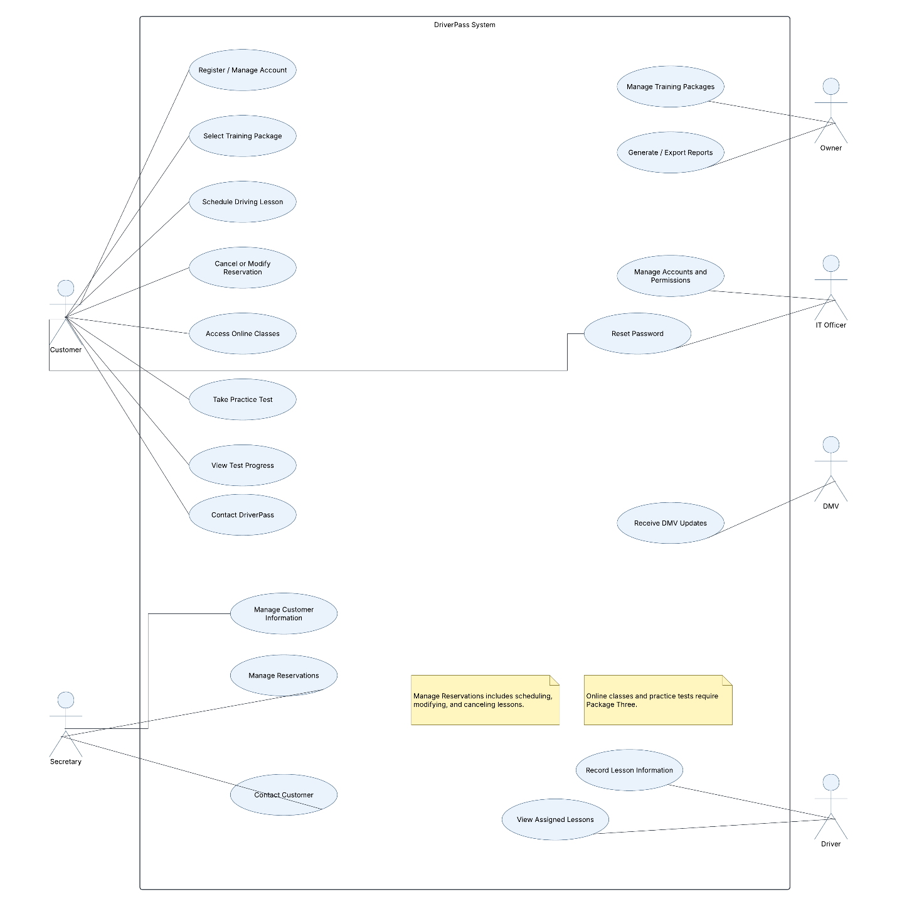

UML Activity Diagrams
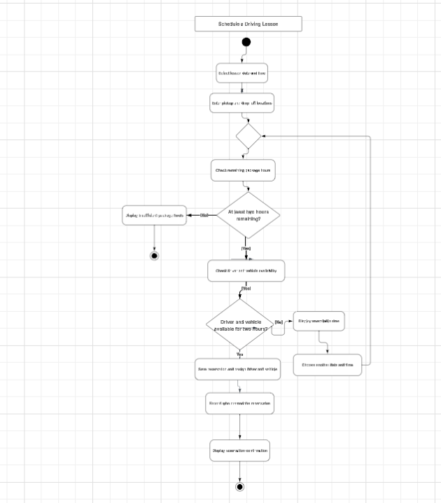
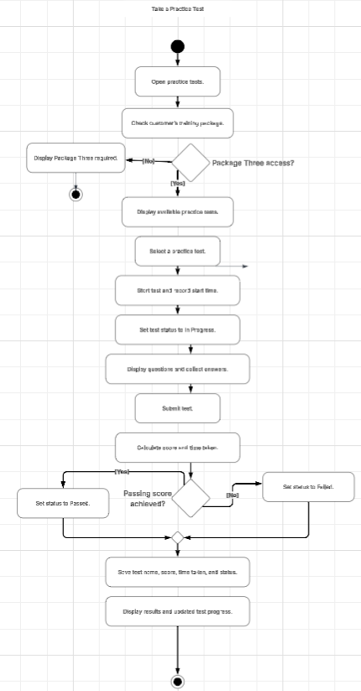

UML Sequence Diagram
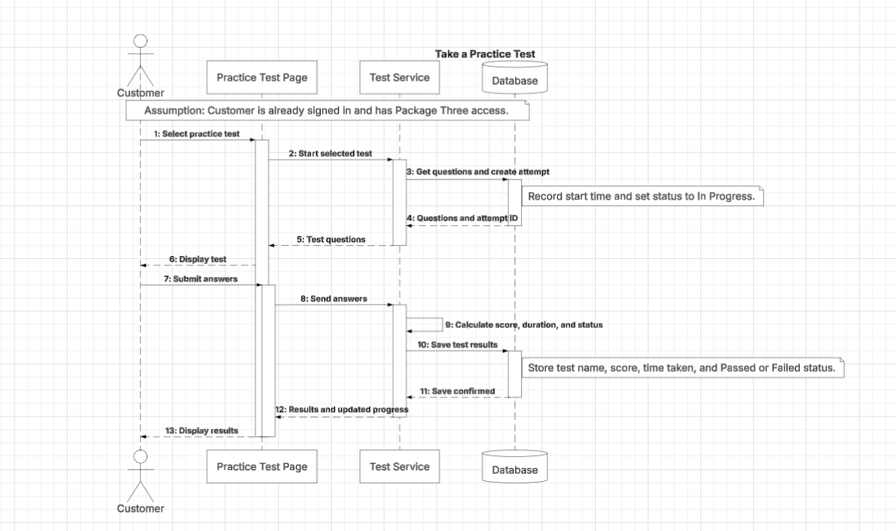

UML Class Diagram
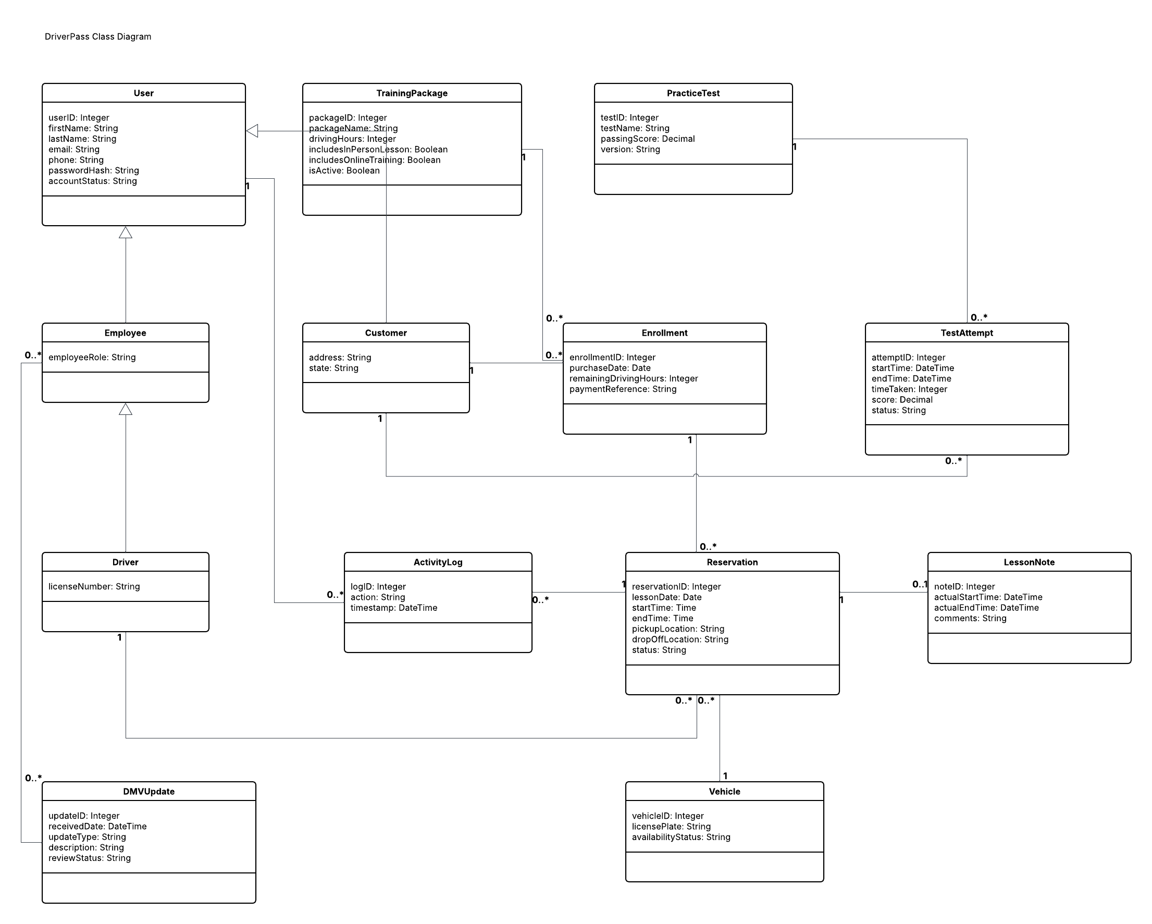

Technical Requirements

The DriverPass system will use a cloud-hosted web application that customers and employees can access through a modern browser on a computer, tablet, or smartphone. Users will need a reliable internet connection to take practice tests, schedule lessons, or update records. DriverPass employees will need office computers and a printer for printed activity reports. The cloud environment will provide the processing power and storage needed to run the application, maintain customer records, and support multiple users at the same time. Hosting resources should be adjustable as the business grows.
The software will include a browser-based interface, an application server, and a centralized relational database. The database will store user accounts, training packages, enrollments, reservations, drivers, vehicles, lesson notes, practice tests, test attempts, and activity logs. Unique identifiers and relationships between records will keep information associated with the correct customer. The scheduling software will check remaining package hours and confirm that a driver and vehicle are available for the full two-hour lesson. It must check availability and save the reservation together to prevent double bookings. The testing software will verify Package Three access, display questions, calculate scores, and save the test name, time taken, and completion status.
Security will require encrypted HTTPS connections, securely hashed passwords, and permissions based on each user’s role. Customers will access their own information, while employees will receive access appropriate to their responsibilities. The IT officer will be able to reset passwords and block accounts. The system will record who creates, modifies, or cancels reservations. A secure payment service should process card information, with the application retaining a payment reference rather than sensitive card details. Automated backups and a tested recovery process will help protect stored information.
Development tools will include an integrated development environment, version control, and testing tools for checking the application’s functions, security, and browser compatibility. Lucidchart will support the UML design documentation. The infrastructure will also need a supported method for receiving DMV updates and notifying employees when rules, policies, or sample questions change. Reports should export in an Excel-compatible format, such as CSV. Downloaded reports can be viewed offline, but changes to live system records will require an internet connection.

